In the coming version

* Rejected checks can be deposit and collected again
* Collected checks in bank can be rejected after it is collected.

new radio button made in deposit check in bank form

Without rejected checks

With rejected checks

If u mark the option with rejected checks system will allow u to re-deposit checks in bank that is canceled

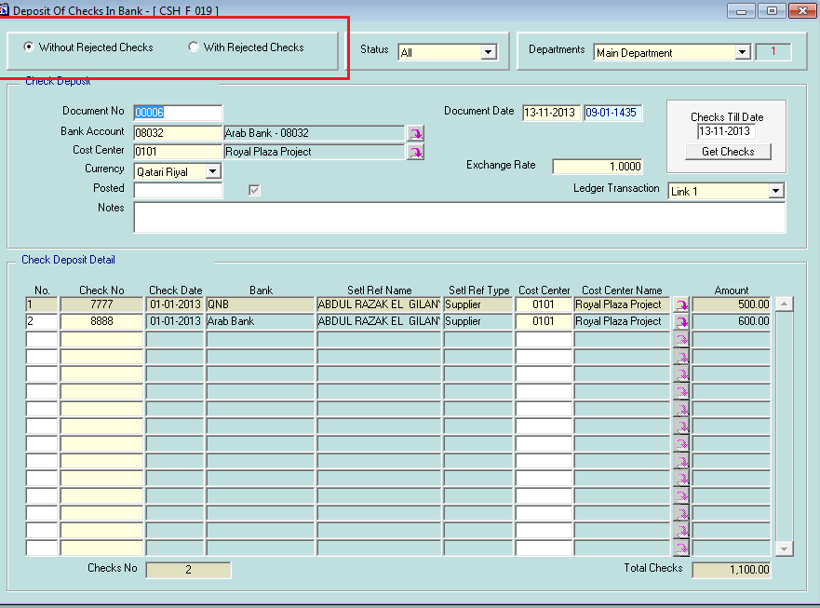

new radio button made in check collection form

Without rejected checks

With rejected checks

If u mark the option with rejected checks system will allow u to collect checks in bank that is canceled

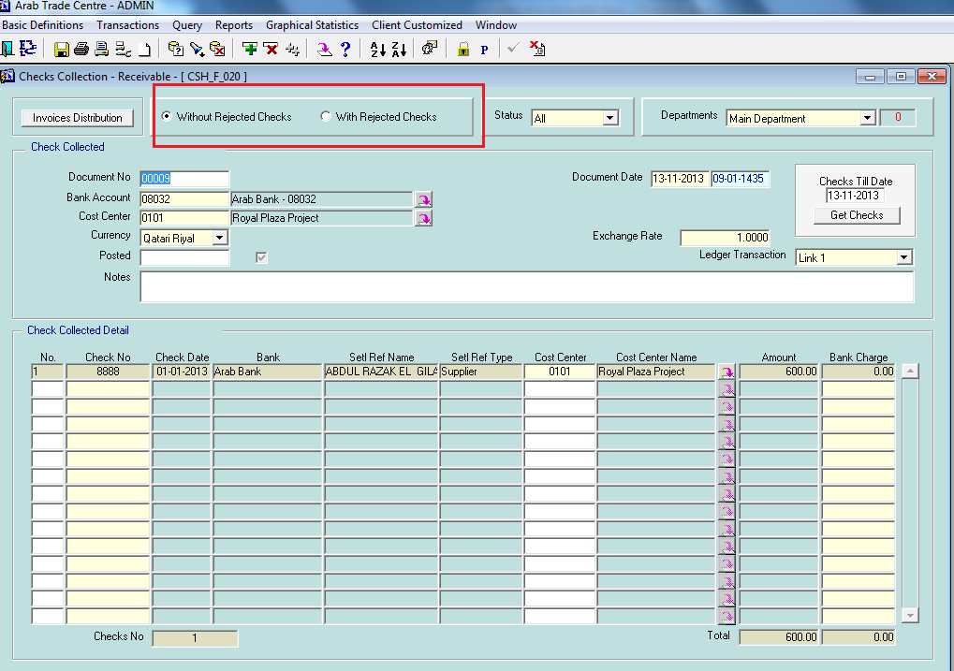

new radio button made in check rejected form

Without canceled checks

With canceled checks

If u mark the option with canceled checks system will allow u to canceled checks in bank that is already collected and return this check to treasury to send it to the client

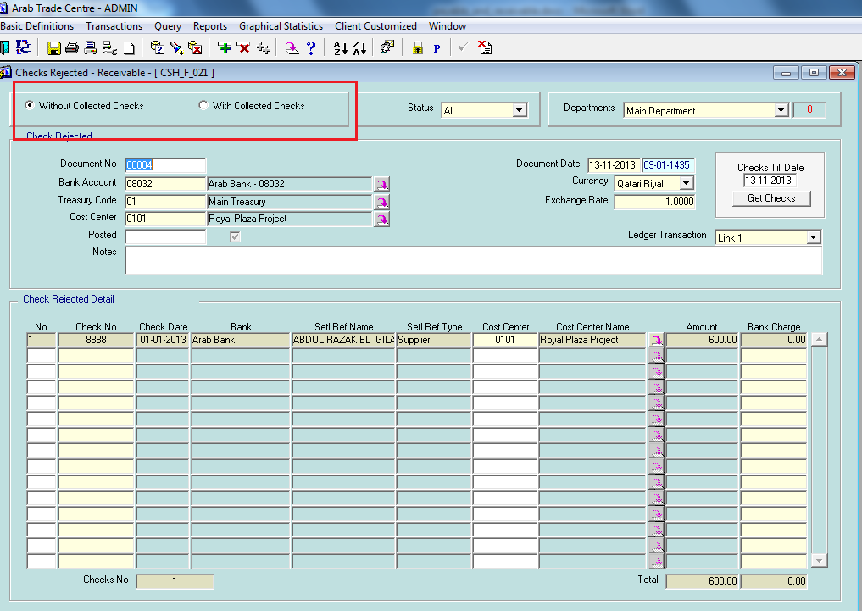

As shown check 1111 is canceled and after that it is re-deposit in bank again

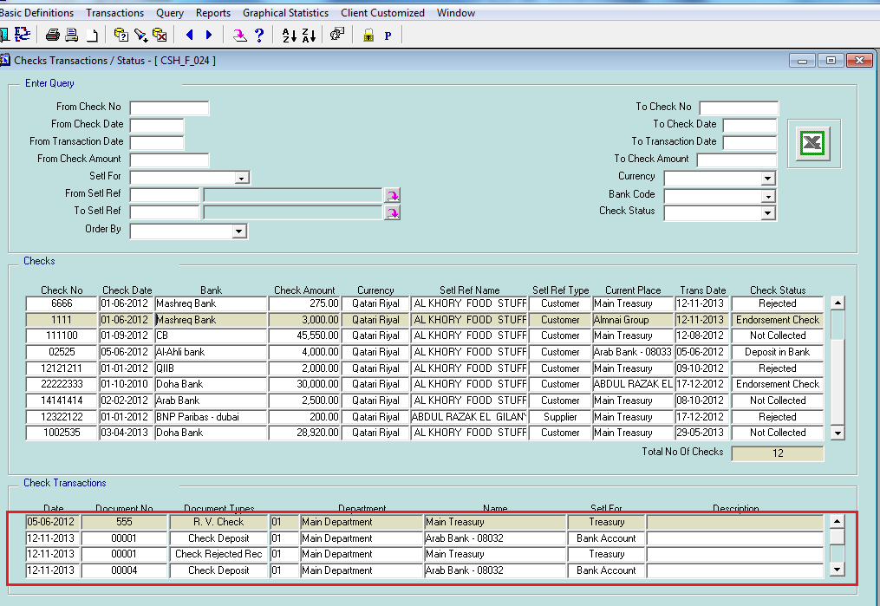

U can also collect canceled checks to bank directly without deposit it to bank 1st

As shown check 6666 is canceled and after that it collected to bank directly.

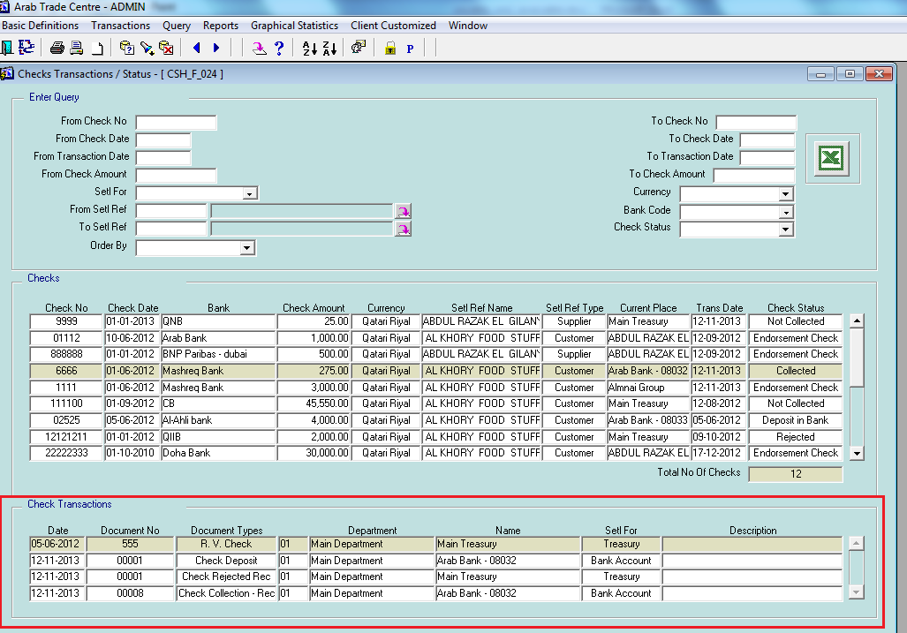

U can also reject check that is already collected

As shown check 8888 is collected to bank and after that it rejected to treasury

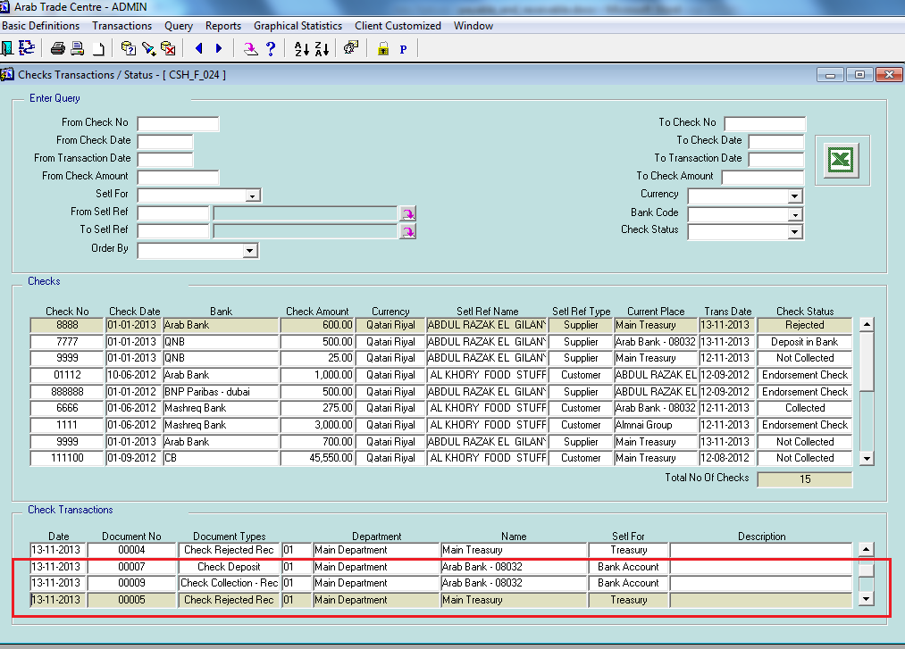

New feature in Bright PDC account for checks in cash and bank management system

In the coming version u can create PDC accounts for customer, supplier, contractor,…

This will delay the effect of current account when u receive or pay check until it collected

First new type of account named pdc account defined

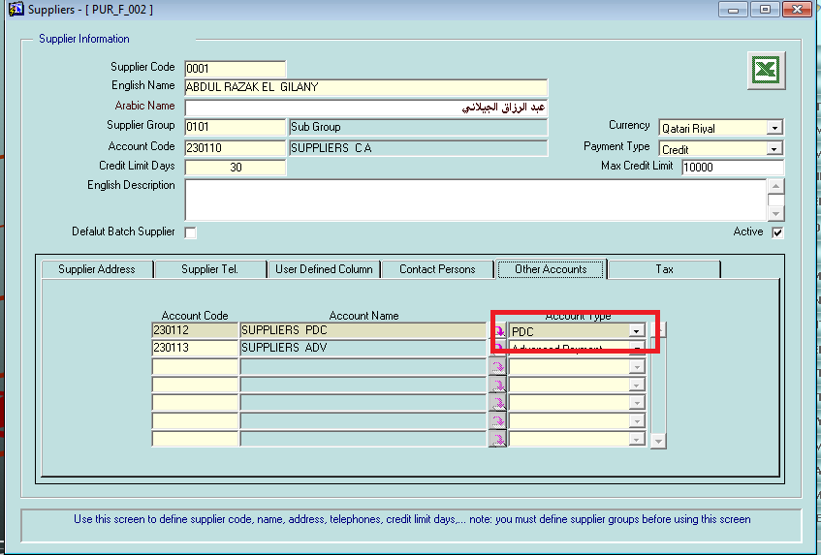

Now if you pay check on the pdc account the system will change the journal generated automatically to affect the pdc account instead of current account and the system will not allow to distribute in invoices since the current account not affected yet and delayed until check collection

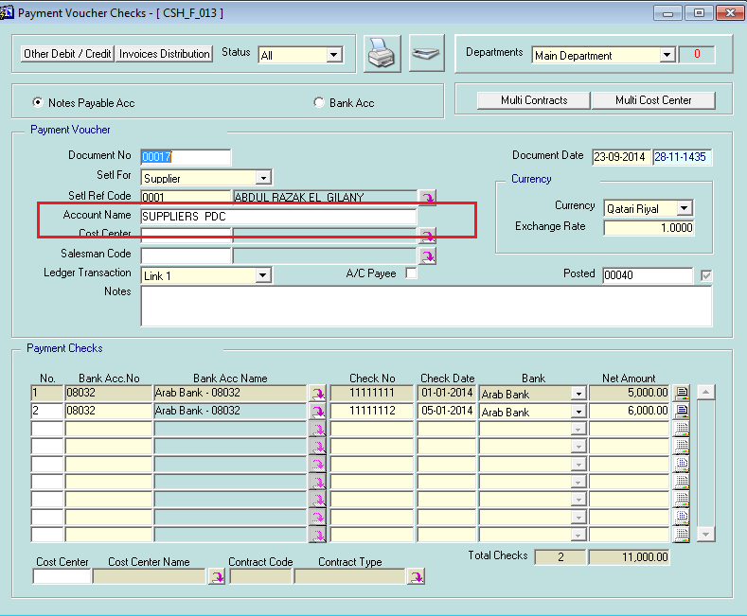

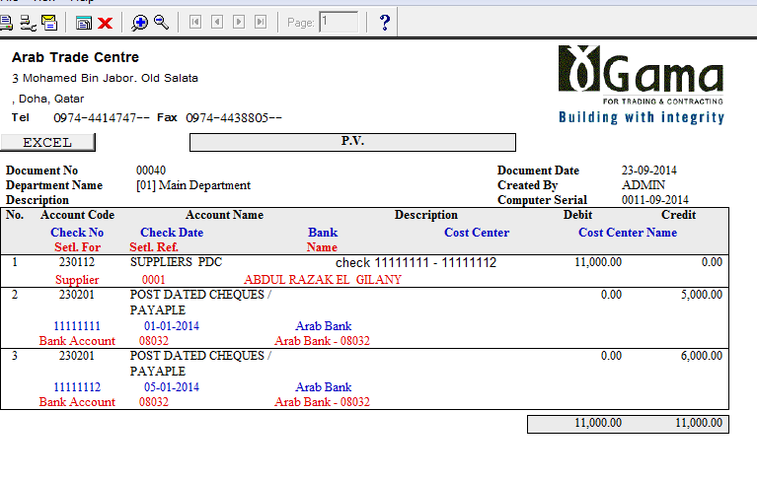

Now when u collect the check that is pdc check the system will work in different way and automatically generate 2 journals as shown

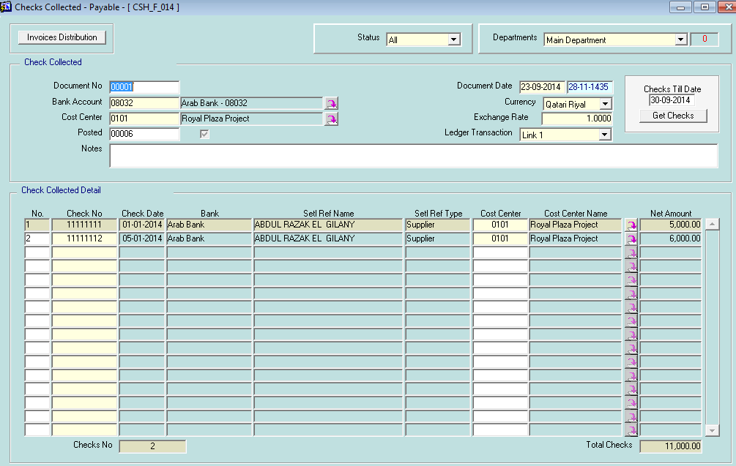

Journal generated changes as shown

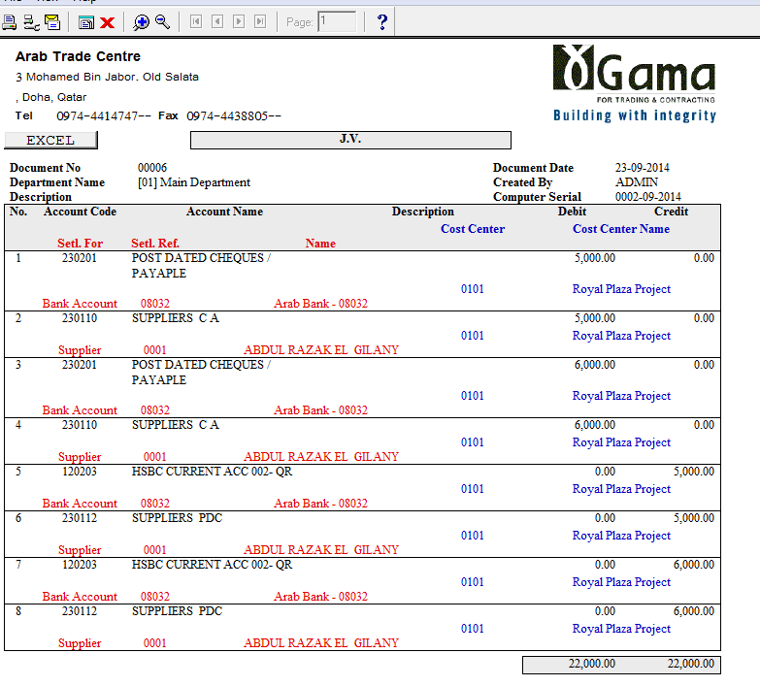

From check collection screen new button added to allow u distribute invoices in collection as shown

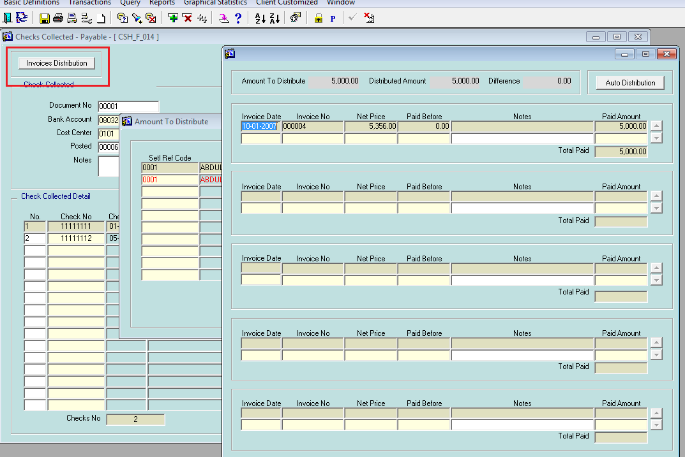

The same mechanism applied for receivable

